Corpus Linguistics for Historians
On January 2, 2014 at the American Historical Association preconference workshop Getting Started in Digital History*, I’ll be giving a session Corpus Linguistics for Historians. Below I explain why I think historians should take a look at corpus linguistics and explain how the software I use, AntConc, works. I have to thank Heather Froehlich for introducing me to this methodology and patiently tutoring me through it over the past 2+ years.

While topic modeling is certainly the better known “distant” or “machine” reading methodology in the United States, corpus linguistics has a long history and is frequently used by scholars in other parts of the world. While I’ve worked some with topic modeling, I’ve come to see some fairly distinctive benefits in corpus linguistics for historians.

Corpus linguistics is the analysis of language in a body of text (such as primary historical sources). The texts comprise what is called the “corpus.” Computer-aided corpus linguistics looks for mathematical relationships between words in a body of texts.

Machine reading of sources provides two advantages for the historian
1. Machines can deal with far larger volume of source material than the human brain can, anything from hundred to hundreds of thousands
2. Machines can find patterns and relationships that the human brain cannot.
Corpus linguistics software works with every word in a given corpus. This is extremely valuable for the “small” words that the human brains tends to slide over when reading [these words are often call “stop words” in machine reading because the programming ignores them before analyzing a corpus]. These words, which have very high frequency in most corpora, are extremely valuable for the historian because they allow us to view complex relationships within corpora that looking only at nouns and verbs does not.

The technical requirements for doing corpus linguistics are relatively low. The two most popular software packages are free (Antconc and Wordsmith). I use Antconc, created by Laurence Anthony, which has the benefit of working in many operating systems (Mac, Windows, Linux). It is extremely easy to install.

Creating a corpus is generally the most daunting obstacle that confronts the historian. Antconc accepts four file formats, txt, xml, htm, and html. Corpora can be loaded as one file or as multiple files depending on the source material and kind of questions you are asking. Creating a corpus can be very simple if you are working with already digitized sources in the public domain to extremely difficult if you are working with handwritten archival documents. Today my examples will come from an ongoing project that explores gender in the six volume history of woman suffrage that I have in 808 individual text files courtesy of Alexander Street Press.

Antconc performs seven different types of analyses, some of which are quite familiar to historians and others that require some explanation.

Overview of Tools (adapted from Laurence Anthony’s excellent documentation)
1. Concordance Tool:
This tool shows search results in a 'KWIC' (KeyWord In Context) format. This allows you to search files and see results in one window.
2. Concordance Plot Tool
This tool shows search results plotted as a 'barcode' format. This allows you to see position where search results appear in target texts. If you loaded your corpora as separate files you will see results expressed for each file.
3. File View Tool
This tool shows the text of individual files. This allows you to investigate in more detail the results generated in other tools of AntConc.
4. Clusters (N‐Grams):
This Clusters Tool shows clusters [words that appear directly juxtaposed in a corpus based on an N set by the user]. In effect it summarizes the results generated in the Concordance Tool or Concordance Plot Tool. The N‐Grams Tool, on the other hand, scans the entire corpus for 'N' (e.g. 1 word, 2 words, …) length clusters. This allows you to find common expressions in a corpus.
5. Collocates:
This tool shows the collocates of a search term. Collocates are words that aco-occurr in a corpus at greater frequency than random chance.
6. Word List:
This tool lists all the words in the corpus and presents them in a list that can be sorted in many ways, including frequency.
7. Keyword List:
This tool shows the words are unusually frequent (or infrequent) in the corpus in comparison with the words in a reference corpus. This is an extremely valuable tool for exploring different discourses. This tool however is subject to some specific conditions, the most of important of which is that the reference corpus must be bigger than the corpus being analyzed.

The documentation for AntConc is excellent. User guides and youtube videos can be found on the Antconc home page.

The following examples will show each of the 7 functions in use based on my ongoing analysis of the History of Woman Suffrage. My research questions revolve around the presence of gender in this corpus, when the word “gender” appears no where.
word list for 154 files attributed male authors. I notice "women" at position 18 with n=1116. The better you know your corpus, the better you will at figuring out what is interesting or significant. This result of "women" is not unexpected of course, although slightly interesting that plural women is higher frequency than singular woman given the locution of 19th century. I decide to go with "women" for our example. Since it is an extremely obvious marker of gendered language, how it is being used in the corpus may be interesting.
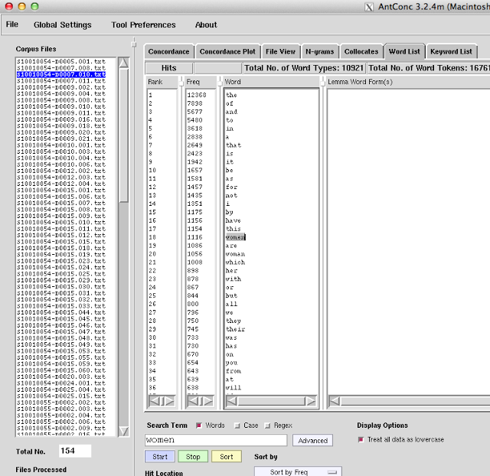

Concordance for "women" shows all 1116 occurrences.
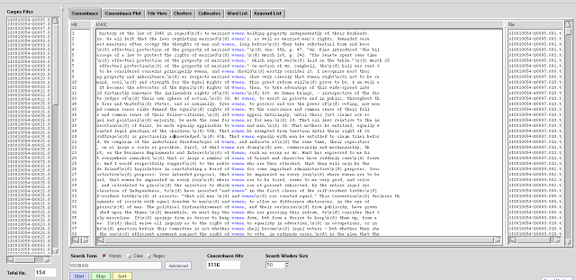

Obviously this is too long a list to read through, so I note by looking in the concordance plot which files have a high density. This has added benefit of showing me the distribution of the word "women" in the files. This view however cannot be exported. I skim to see which files are densest since as would be expected all 154 files contain at least 1 occurrence of "women." I note that one file has 197 occurrences so I click on that to view in "file view." I see it is a summary by Theodore Stanton, Elizabeth Cady Stanton's son, of his work The Woman Question In Europe. This is definitely interesting to me so I make a note of it. I'd continue explore these files noting those that seem particularly dense in the usage of women as places to start for close reading. I'd also note where "women" is not present at very high frequency. What are those items talking about then in a volume about woman suffrage?
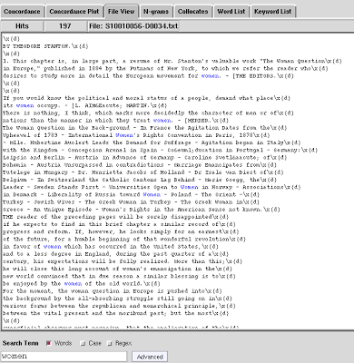

Collocates, words that appear together in a corpus at a frequency greater than chance, are a far more interesting way to explore a corpus that word frequency. The top collocate for "women"is "of" and "of women" is also the top cluster (this is not always the case, note the the 2nd and 3rd highest collocates are not the 2nd and 3rd highest clusters). However we need to look at the "stat" column to determine if the collocations are statistically significant [see excellent explanation by Richard Xiao‎] The value needs to be 3 or higher. There are two interesting collocates with stat values higher than 3 with fairly high frequency, "are" and "married." While I would definitely explore "married women" for our example, I'm using "are."
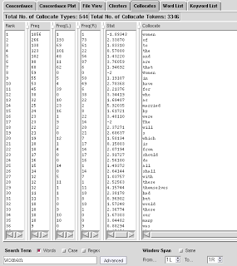
Looking in the cluster view I see "women are" occurs 64 times making it the 4th most frequent cluster of "women _____" [are women N=9].
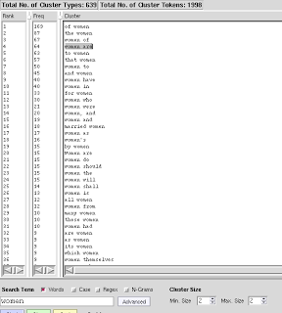
and checking N-grams reveals that by frequency "women are" is in the top 100 bi-grams in the corpus
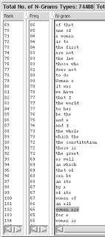
The concordance view and concordance plot of "women are" reveals how it is used and where it is used. Again it has high distribution, appearing in 142 of the 154 files. The densest file is again Stanton's (which is the longest file by a male author), so I note that, and continue exploring. I'm down to numbers that make it possible to read "women are" in context in all occurrences relatively quickly, and I could correlate author metadata for the items to determine is specific usages of "women are" occur in speeches versus say private letters.
Finally I compare the usage of "women" in the files by male authors as compared to 294 items authored by females. Keyness reveals that "women" is a statistical significant negative key word, which means male authors used it less frequently than female authors. This is definitely interesting and I would then probably move to exploring all of the above in female authored items in my corpus.

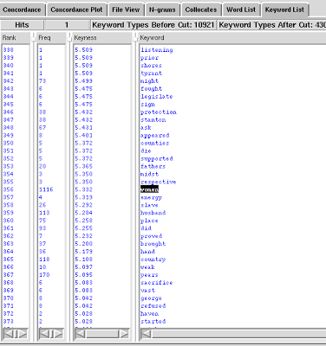

Note that the process outlined relies on a back and forth between machine reading of the texts and close readings of the individual items. I've keyed in on Stanton's essay already as an important male authored text in the corpus that deals with gender. This I probably could have done without the aid of a computer based on its size and title alone. However while "women are" obviously doesn't provide me all the answers I'd want to know about how male and female authors express gender in the six volume History of Woman Suffrage, it gives me a place to start (79 occurrences of "women are" in male authored files) and leads me to other places to look further (in female corpus following negative key words).
In a full corpus linguistics analysis I'd repeat the above in many different ways. Exploring how male and female authors use "women" and then "men" for example gets at deeper aspects of gender in the corpus. I would look for gendered pronouns, which is actually where I started the project with his/her, and terms of address (Mrs/Miss/Mr). I'd exploring trigrams of "women" "women and men" "women not men" and "women or men." I could separate out the items by the very well known suffragists like Stanton and Anthony, and compare them to the 172 items by authors who appears only once in the corpus to see if differences emerged there. I could parse the corpus by location of authors to get a view of potential regional variations. All the while I'd be comparing patterns and shifts over time and space, which is what historians do. I'd just be doing it with words I'd have ignored and with a volume of sources I never could have used.

FORCE DIRECTED GRAPHS, INTERACTIVE, STATIC, WORD FREQUENCY AND COLLOCATION

FORCE-DIRECTED DIAGRAM: MEMCONS AND TELCONS ‘TEXTPLOT’
2 COMMENTS

Static ‘Textplot’ of both corpora
This is a network of the 1300 most frequent words in each corpus, related according to their mutual similarity in probability distributions across the span 1969-1977. This was accomplished using the fabulous ‘textplot‘ software, written by David McClure.
In both cases, the general time axis is left-to-right (the layouts were rotated in gephi after the gml files were generated, and then those gephi-generated files were run through the ‘kissinger’ branch of the software found at the humanist github repository.
In the memcons, the ‘tendrils of specificity’ (the long patterns of increasingly specific words emerging like pseudopods in similarly-colored Modularity Classes from each diagram’s center) relate quite distinctly to areas of geopolitical focus, such as the Soviet Union, Japan, China, the Middle East, and Vietnam, among others.
Memcons ‘Textplot’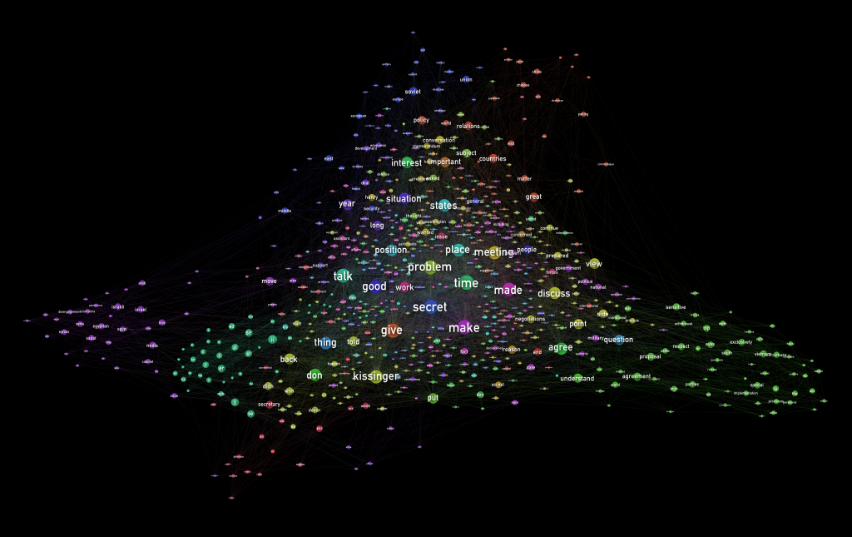
In the Telcons textplot, the ‘tendrils’ are most closely related to what appear to be large swaths of the telcons bearing the varying stamps marking the documents’ former classification and declassification statuses:
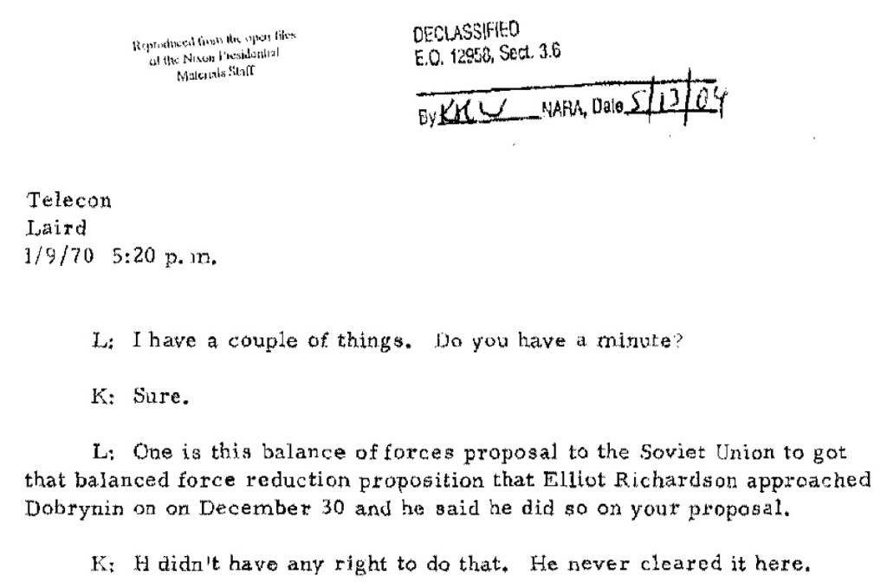
There are also some clusters that appear to be based around geopolitical topics (those related to Vietnam, for example). Also noteworthy are: 1., a grouping that appears related to a section of the documentation with increased OCR error rates or other improperly converted material (this grouping may also reflect the use of initials in the transcripts, although it’s unclear at this time to what degree.) and 2., the placement of the first names of Kissinger’s wife Nancy and son David, distinctly outside the general word networks.
Telcons ‘Textplot’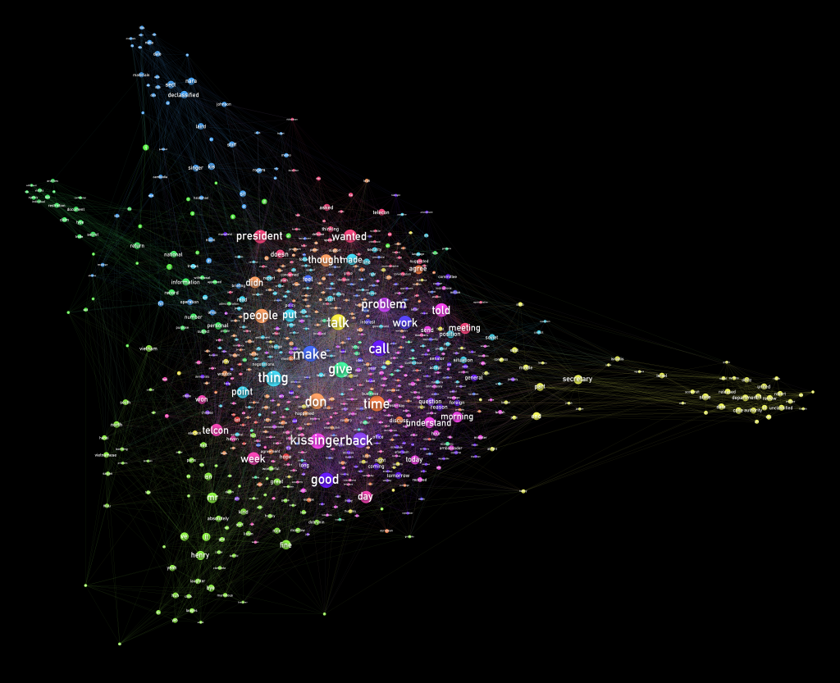
It’s important to note that while there are certainly similarities between the nodes comprising the various ‘tendrils of specificity’, textplot’s similarity calculation is based on a calculation of word frequency across the corpus as a whole, without distinction at the document level. This can result in contrasting results to collocation, topic modeling and other analyses that can operate at the document or ‘chunk’ level, and the difference can be instructive in some cases.
For example, the presence of ‘bombing’ is among the most frequent 1300 words in the telcons, nestled tightly within the cluster of words related to Vietnam. The word does not appear among the most frequent in the memcons. Given the differences in word composition between the two corpora (familiarity, % of nouns/place names, formailty, detail, provenance, redaction, etc.), this is to be expected, but nevertheless the word’s presence is still interesting for a few reasons.
Zoomed-in on ‘bombing’ within the
Vietnam-related cluster of telcons document documen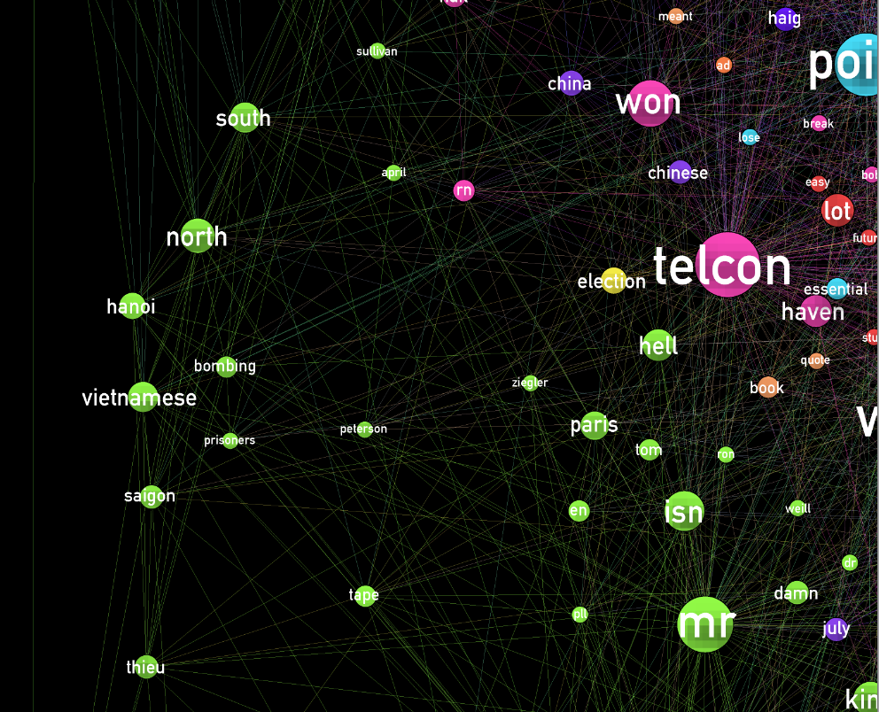
Among a number of possible reasons, the finding is interesting because coming as a recent finding (2014-2015) it is a non-linear ‘post-indication’ of the value of the earlier decision (2012-2013) to do collocation analysis using bombing as the target word. This is especially true given the resulting finding that indicates a potentially significant distribution in the collocation MI-scores between ‘bombing’ and those words describing Vietnam, versus those that describe the country’s neighbors in Indochina.
A recent finding providing possible insight regarding an earlier, intuitive research decision, it strikes me that this is a poweful, non-linear example of the value of visualization as an ongoing process, rather than a one-time production process that results in a specific finding. Additionally, this makes me ponder about cases where the reasons for one’s instincts and biases (in my case, the selection of ‘bombing’ as a target word) may sometimes be seen in the data.
Interactive Textplots
David’s ‘humanist‘ software was then used to create an interactive d3-based browser based on the textplot output gml for each corpus. Without Modularity Class coloring of the nodes, this ‘alpha’ interactive version is (also for the moment) less able to communicate the groups within the distribution of words than the static diagrams.

Visualizing Gender in HIstory of Woman Suffrage
nb “Under this name she is fitly described”: A Digital History of Gender in the History of Woman Suffrage, Women and Social Movements, forthcoming March 2015
Moving towards publication, jump to next red if you're curious where I started.
project inspired by this quote and conducted with the kind assistance along the way of Ellen DuBois
Subjecting the subject of woman suffrage to a gender history approach must surmount the obstacle that the term “gender” is absent from the primary sources. But this does not mean that the underlying concepts packed into the contemporary use of the term are absent. Tani Barlow has approached the history of women’s rights (including suffrage) in China by tracing the shifting Chinese language terms for woman/female. The English language does not provide such an easy entry into this project – though the terms for the political movement were numerous, shifting, and subtly different in connotation – woman suffrage, equal suffrage, votes for women, home protection, women’s suffrage, etc. Ellen DuBois
More gender in History of Woman Suffrage June 11
Female appears in about 20% of the male authored items in the History of Woman Suffrage while male appears in about half of the male authored files. I first looked at significant patterns of usage, clusters (table 2). Male clusters reflect a legal discourse centering on men’s role as “citizens” and the rights thereof “male voter. ” “Female suffrage” is one ways the suffrage demand was articulated (graph 3). Other clusters pertain to apsects of the movement as well “female delegates” to the conventions for example. Interestingly two "sutdents" and "physicians" refer to suffrage movement overlaps with women’s education.
Table 2
male sex | female sex
male and | female suffrage
male citizens | female delegates
male citizen | female students
male members | female physician
male voters | Female portion
I got curious about who was using female and male in the corpus, so before I poked around the above results anymore I ran that analysis. When I visualized those results by year I noticed female peaked 1850s (data viz 3, male1880s (data viz 4). Next up, digging to figure out why!
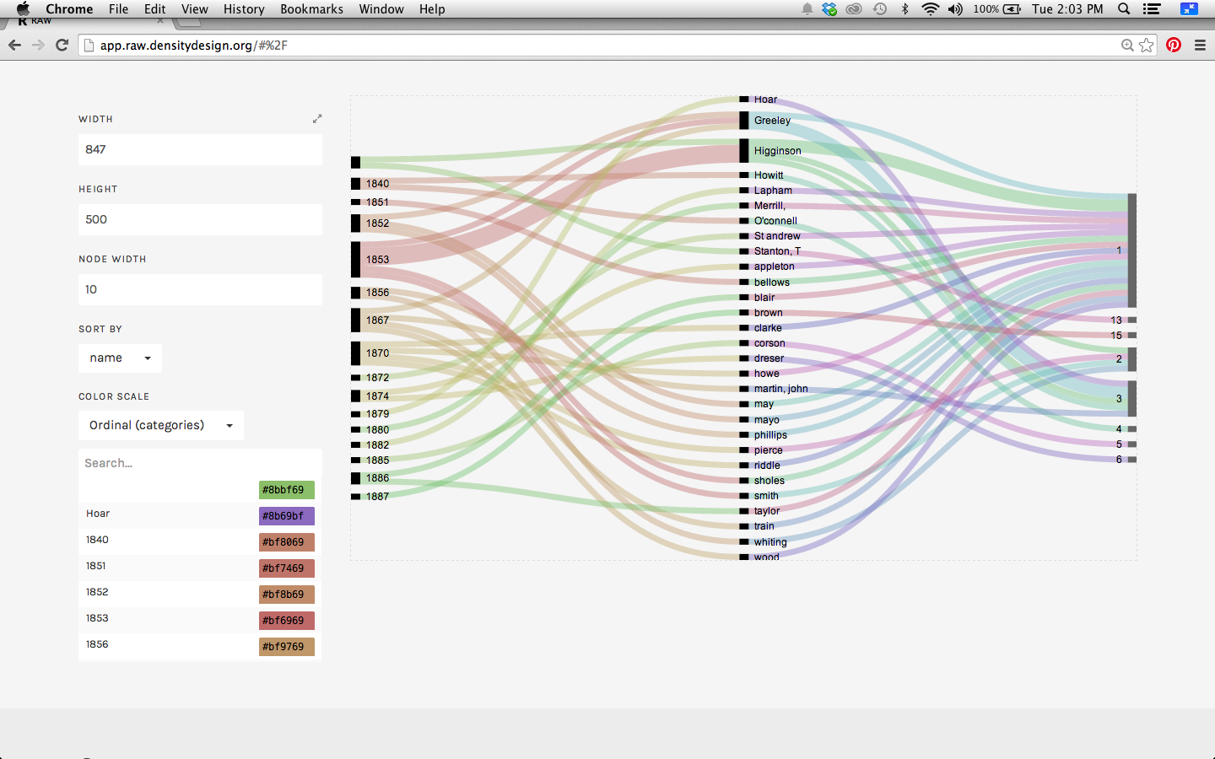
DataViz 3

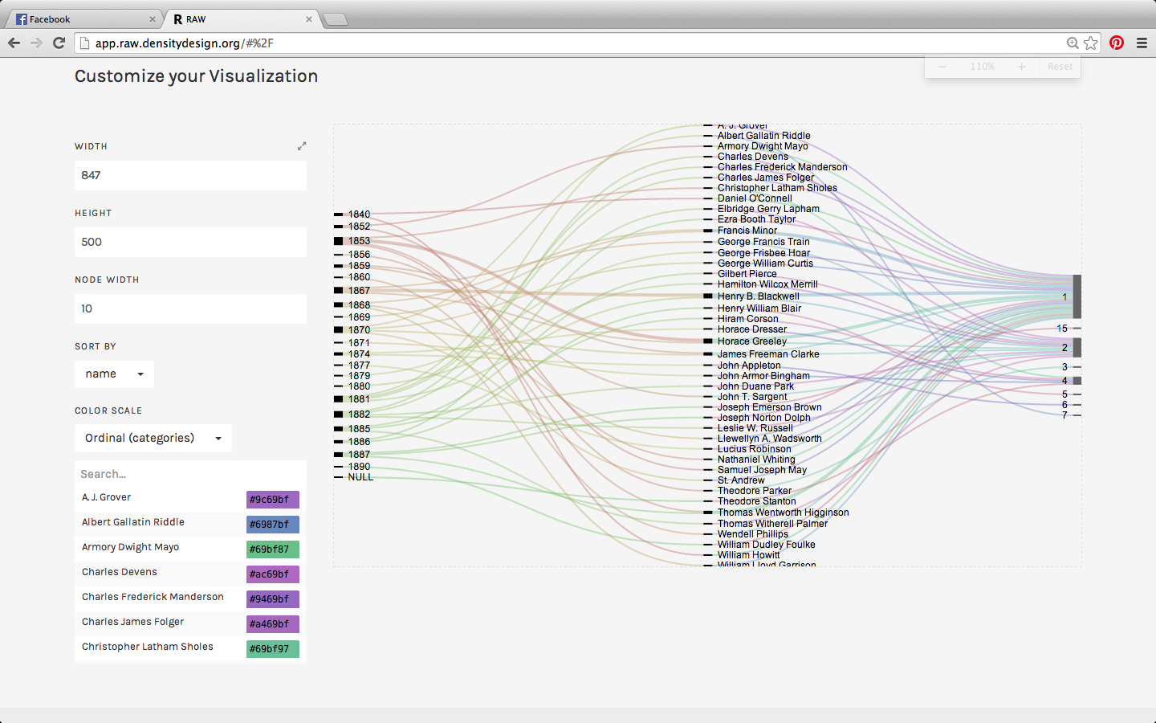
Data Viz 4
While in my iterative process of moving from the computer analysis of the texts, to reading the files, I found this quote I LOVE that speaks gender
“Man-masculine is not endowed by his Creator with certain inalienable rights because he is male, but because he is human; and when, in virtue of our strong andsuperior physical capacity, we deny to man-feminine the rights which are ours only in virtue of our humanity" C.L. Sholes Minority Report, Committee on Expiration and Reenactment of Laws, Wisconsin, 1853
Today I spent some time with male and female in context which caused me to refine my preliminary diarchonic analysis of Data Viz 3 and 4. Uses of male divide pretty sharply at the Civil War, due to the debates over first the Reconstruction Era amendments to the Constitution and then to various State battles to win women's suffrage, which hinged on the word male. The use of male prior to the Civil war in the male corpus is almost exclusively religious. The uses of female don't exhibit these stark divides, although I found it fascinating that prior to the Civil War, neither
female citizen nor female suffrage appeared in the male corpus. The most predominate cluster pre-Civil War was female sex or just plain female.
These distinctions are far less clear in the female corpus, which is smaller in usage of female and male (see keyness table below). Is is relative absence of female an effort by women authors to draw attention away from their sex? Is the relative absence of the religious connotations seen in the male corpus a reflection of the fact that women were excluded from the clergy in virtually all religions during this time and not seen as fit to offer religious pronouncements?
Leaving behind why the women don't use words like men, I started to explore the female corpus. I looked at a distinction I had previous identified (table 1) in the female corpus, her husband (graph 2). I examined lines not with only her husband but collocates, which is to say her within 5 words to the right or left of husband. As usual Heather Froelich saved my ass here by pointing out I might want to reconsider methodology. See her excellent piece paper on gender-specific possession.
her husband is spread over a long range of dates, from 1848-1902, and appears in about 13% of items. her husband appears disproportionately in items from the antebellum period (only about 25% of the author, date attributed files pre-date the Civil War, but 35% of items containing her husband are antebellum).
Scanning the KWIC reveals that uses of her husband are extremely negative. Modifiers for husband includ
Preceding words are against, abandoned, fought, ill-treated, cruelty, fear, injuries, subjected. However, words like consent, death, property, protection invoke a second connotation, that of a legal discourse.
Looking at the lines containing her husband I coded by searching for the following words under categories death, negative connotations, the law, property, coverture, family, and rights. (table 3) then sorted chronologically.

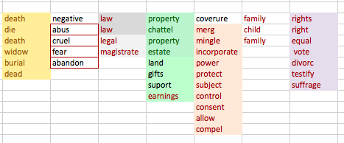
table 3 words used to code each category

Distinctive uses around coverture are most prominent in both periods, as we might expect, especially since I searched for the highest number of terms under that category. Chronological shifts occurred though in terms of the sense of rights (both in general and in terms of specific rights) in antebellum era items which seems to fade away during the postbellum period, giving the legal discourse more prominence.

Data Viz #5 NB 1886 is the date of publication for Volume 3 HWS. The 38 items with that date are chapter headings, appendix, and Isabella Beecher Hooker's memoir). I'm curious about the year 1850 so I pull up those items.
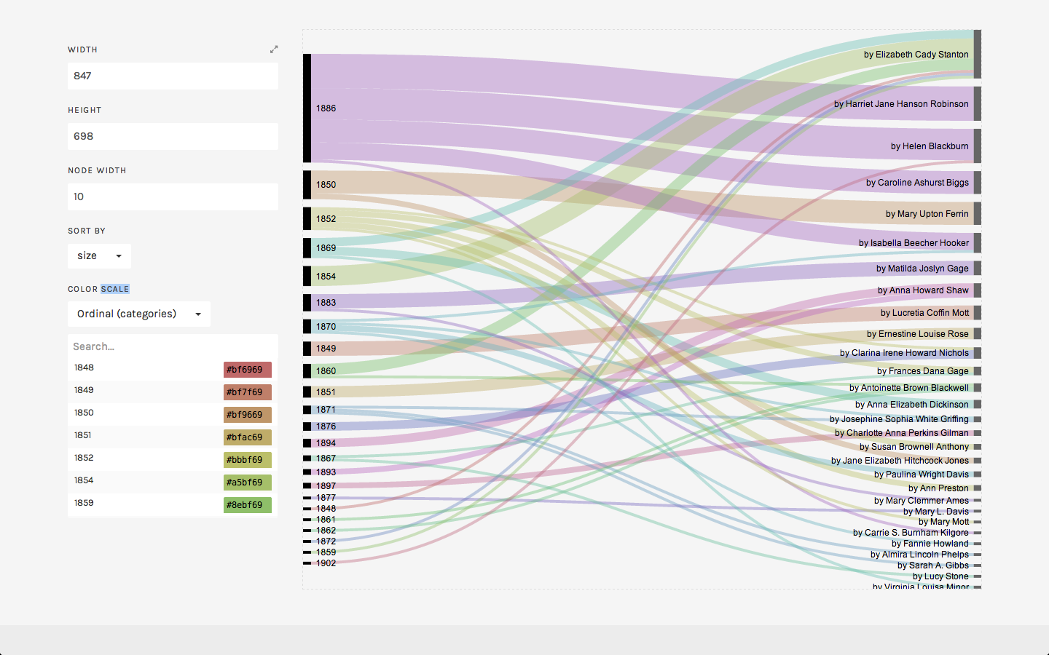
Data Viz #5 her husband weight by total number of items containing per year

Mary Upton Ferrin's ADDRESS TO THE JUDICIARY COMMITTEE OF THE MASSACHUSETTS LEGISLATURE concerned the property rights of married women and the right of divorce. About half of the instances of "her husband derive from the anecdotes Mrs. Ferrrin used throughout her appeal.
A similar argument was made in an Address to the Women of Ohio, 1850 by Jane Elizabeth Hitchcock Jones who also provided this anecdote "In Hindostan, the evidence of woman is not received in a court of justice. The Hindu wife, when her husband dies, must yield implicit obedience to the oldest son." This focus on married wmen's property rights is what I'd expect to find in 1850. I'm not quite so clear however about how her husband would fit into the rhetoric of 1869. The Speech of Anna Dickinson to the Chicago Woman Suffrage Convention, 1869, in which she claims to have been exiting the hall due to the stifling heat, only to be called back to the platform by dissent voiced as follows
"that woman is abundantly represented by some man of her family; that when a woman lifts herself up in opposition against her husband, she lifts herself up, if I properly and rightly understood the declaration, against God; that the inspired assertion is that the husband is the head of the wife."
In this case, the instance of her husband is a sort of rhetorical trope attributed to the opposition to woman suffrage. It is quite interesting through in terms of my analysis of male in the male-authored items, in which I noted in the 1850s a strong religious slant to items in History of Woman Suffrage.
Virginia Louisa Minor, who would go on to be plaintiff in the landmark Supreme Court Decision Minor v Happersett, gave an address in 1869 to a suffrage convention in which she offered a Nativist/ xenophobic rationale for woman suffrage
is it presumable that a foreign citizen is intended to be placed higher than one born on our soil? Under our Constitution and laws, woman is a naturalized citizen with her husband. There are men in this town to-day, to my certain knowledge, who have had this boon of citizenship thrust upon them, who scorned the name, and who freely claimed allegiance to a foreign power.
Finally Elizabeth Cady Stanton offered an example of a widow who carried on her husband's business successfully.

From data viz #6 Elizabeth Cady Stanton is a very frequent user of her husband but then again she is a very frequent contributor to the History of Woman Suffrage. By the number of items she authored contain her husband are proportionate to the percentage of items she contributed. In order to determine whether her usage is skewed in terms of words count, I need to hand separate the files attributed to her to determine word count, which I haven't done yet. However what I can do is compare her use of her husband over time to see if it shifted. I suspect that her husband reflects the anecdotes used to personalize the struggle for woman's rights and suffrage.

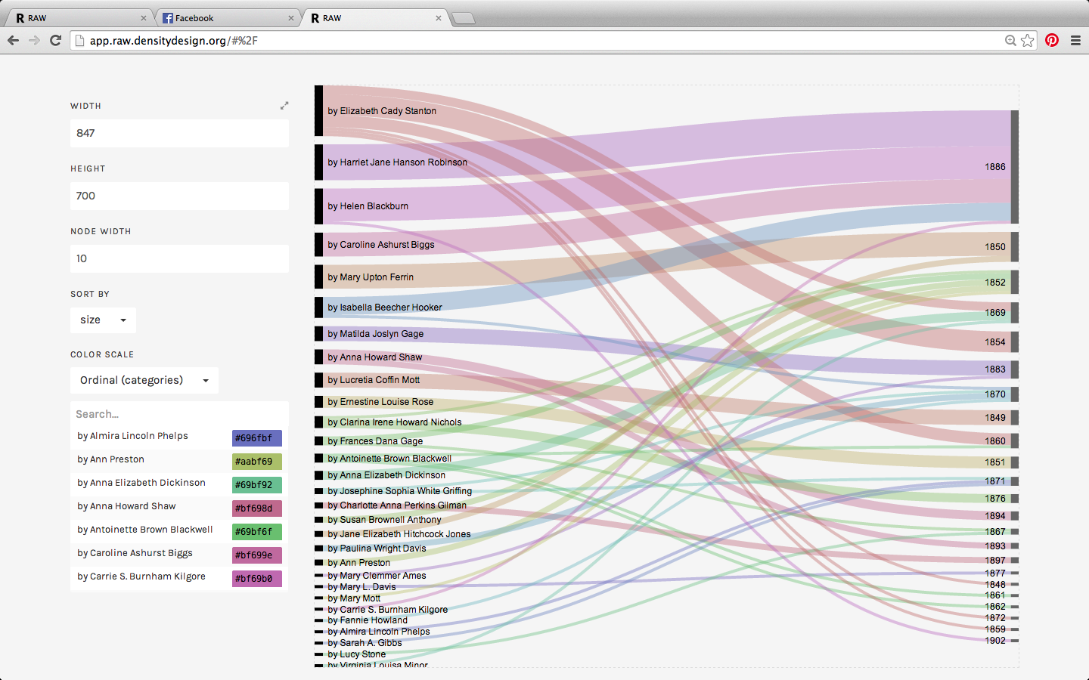
Data Viz #6 her husband by author not corrected by corpus contribution

In an 1854 address to the New York State Legislature, advocating for married women's rights, Stanton ran the gamut from invoking the slavey analogy to implying that coverture encouraged women's immoral behavior.
"The wife who inherits no property holds about the same legal position
that does the slave on the Southern plantation. She can own nothing,
sell nothing. She has no right even to the wages she earns; her person,
her time, her services are the property of another. She can not testify,
in many cases, against her husband. She can get no redress for wrongs
in her own name in any court of justice. She can neither sue nor be sued.
She is not held morally responsible for any crime committed in the presence
of her husband, so completely is her very existence supposed by the
law to be merged in that of another. Think of it; your wives may be thieves,
libelers, burglars, incendiaries, and for crimes like these they are not held
amenable to the laws of the land, if they but commit them in your dread
presence. For them, alas! there is no higher law than the will of man."
She also invoked a xenophobic comparison between the status of widows in the United States to the practice of sati
"Man has ever manifested a wish that the world should indeed be a blank to the companion whom he leaves behind him. The Hindoo makes that wish a law, and burns the widow on the funeral pyre of her husband; but the civilized man, impressed with a different view of the sacredness of life, takes a less summary mode of drawing his
beloved partner after him; he does it by the deprivation and starvation of the
flesh, and the humiliation and mortification of the spirit.
In Appeal and Petition to the Women of New York, 1859
To the Senate and Assembly of the State of New York:
The undersigned, citizens of - - , New York, respectfully ask that you will take
measures to submit to the people an amendment of the Constitution, allowing women to
vote and hold office. And that you will enact laws securing to married women the full
and entire control of all property originally belonging to them, and of their earnings during
marriage; and making the rights of the wife over the children the same as a husband
enjoys, and the rights of a widow, as to her children, and as to the property left by herhusband, the same that a husband has in the property and over the children of his
deceased wife."
Moving to the postbellum period, Stanton's usage reflects the general shift I observed (discussed below), towards an increasingly legal applications in this period. In a speech to the Senate Judiciary Committee in 1872
"In England, where the right to vote is based on property and not person, the feme sole freeholder has exercised her right all along. In her earliest history we find records of decisions in courts of her right to do so, and discussions on that point by able lawyers and judges. The feme sole voted in person; when married, her husband represented her property, and voted in her stead; and the moment the breath went out of his body, she assumed again the burden of disposing of her own income and the onerous duty of representing herself in the Government.
The last usage of her husband in History of WomanSuffrage is by Charlotte Perkins Gilman in an 1897 speech to the NAWSA. "the mother shall be sacrificed to her children, and incidentally to her husband" takes on additional meaning coming from the mouth of a woman denounced as both scandalous for divorcing her husband and as an unnatural mother for sending her child back to be raised by her ex-husband and his second wife.
Coming tomorrow, the husband vs her husband, dataviz teaser below
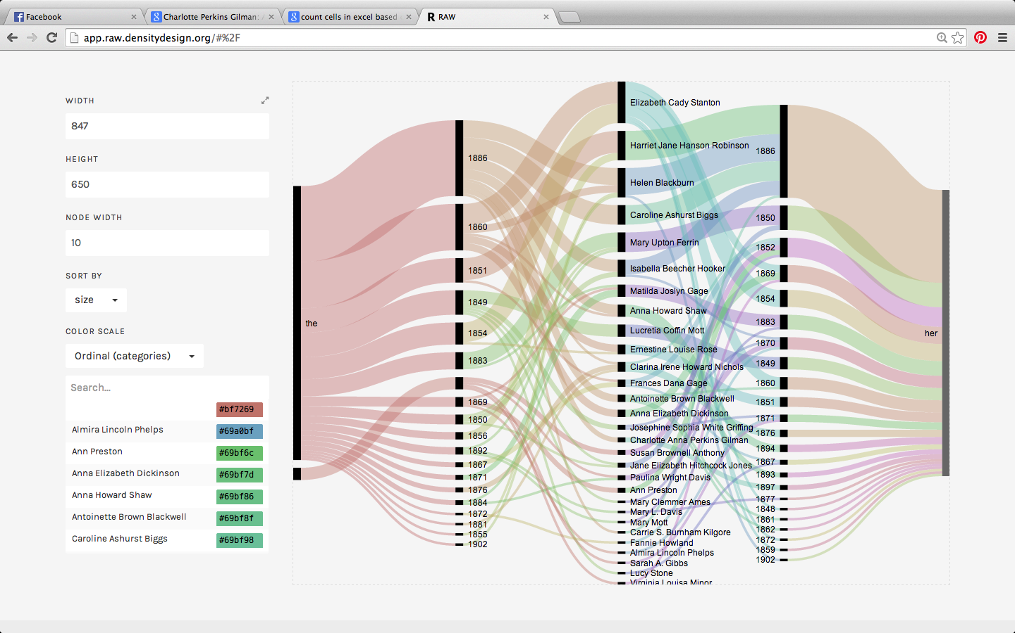

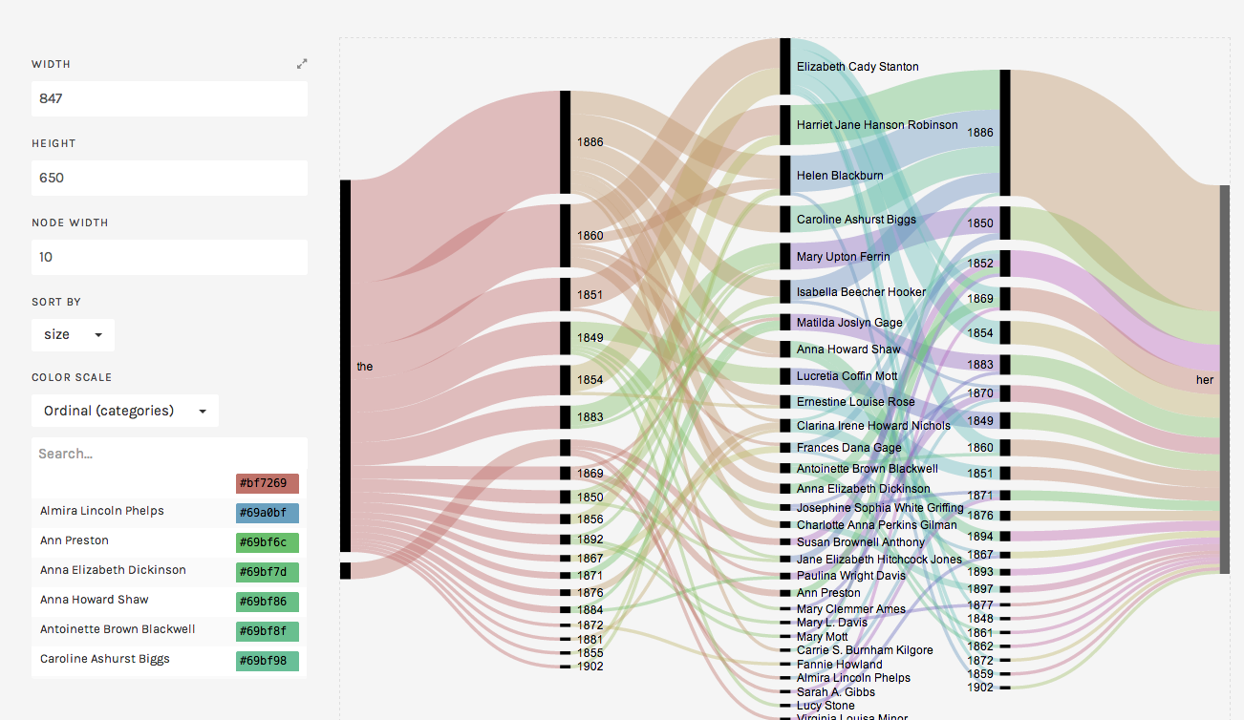
Playing with the medatadata, which is not complete!!!!!
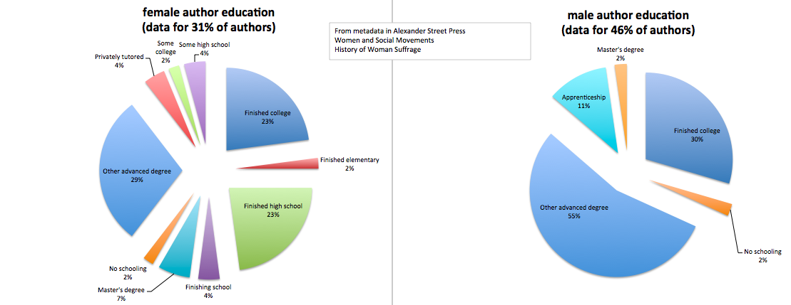
Educational attainment by sex of author

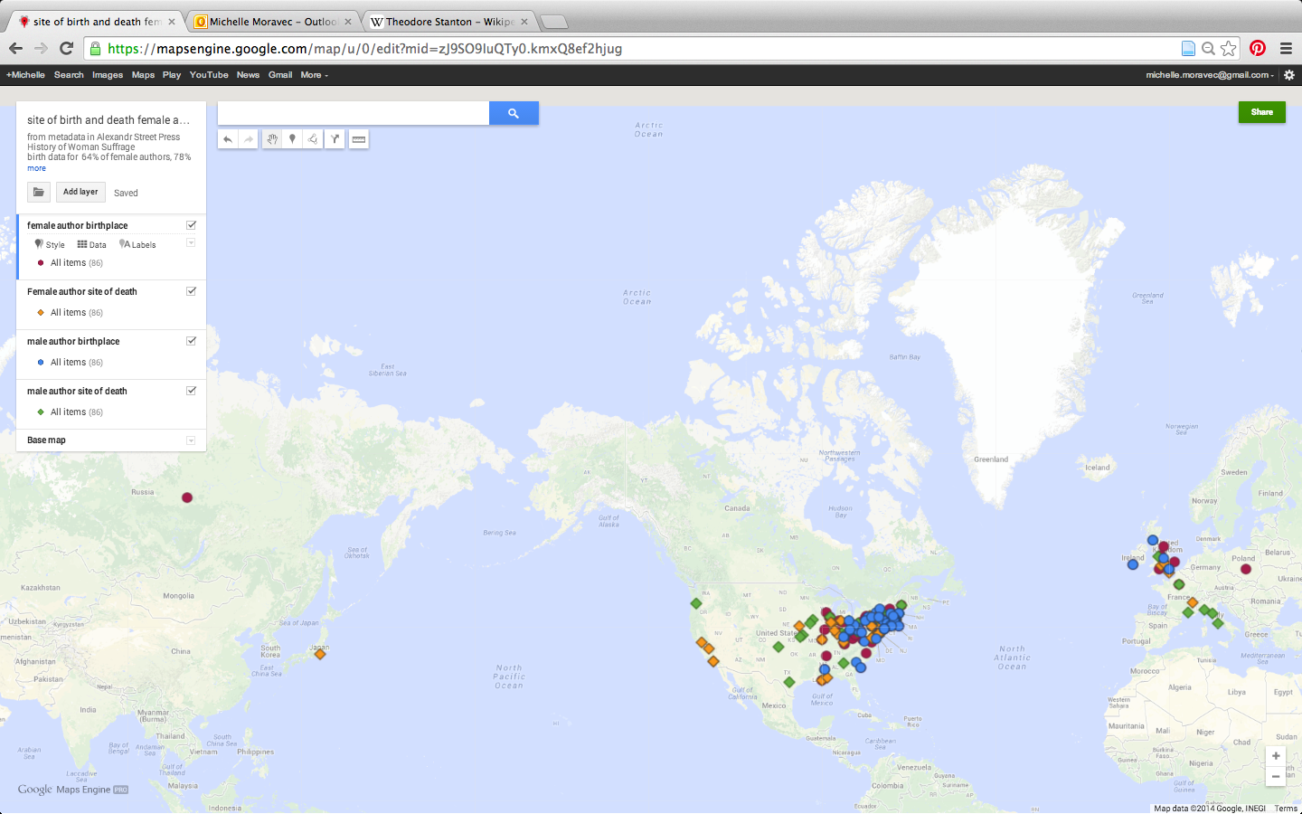
site of natality and death, click to go to map
post-script, Ellen asked me about diachronic shift in how demands for the vote were articulated. Below is the distribution of equal, female, woman, woman's suffrage by VOLUME of HWS (which are only roughly chronological). This graph is not corrected for corpus size.
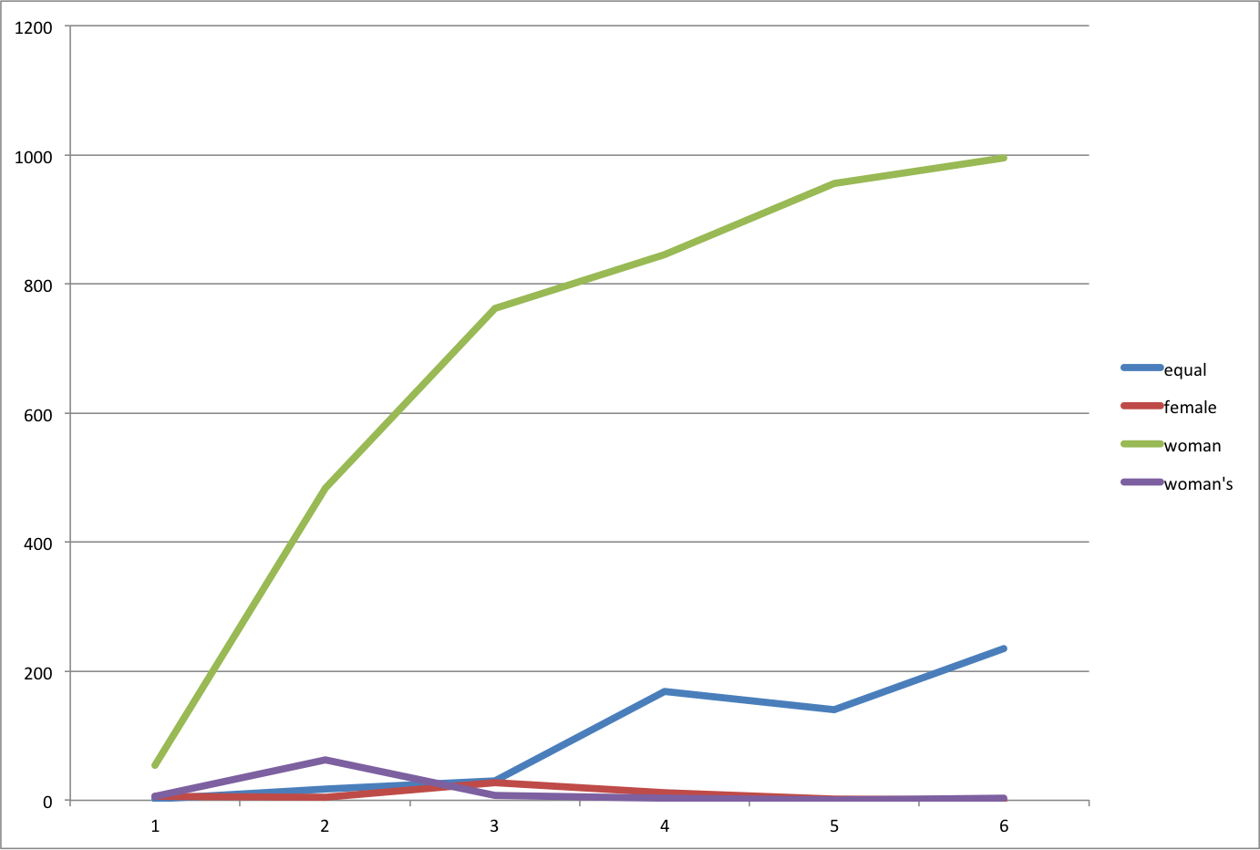
documenting process as project unfolds. all results are preliminary and subject to change!
For the American Historical Association Meetings, Jan 2014 The History of Woman Suffrage (HWS) is a six volume scrapbook of sorts started by Elizabeth Cady Stanton and Susan B Anthony that retrospectively documents the eight decades and more of the movement for woman suffrage. Although the text is long out of copyright, I am lucky to be working with the beautifully enhanced digital version from Alexander Street Press's Women and Social Movements, which comes with the most amazing metadata I've worked with so far.
As I'm not a historian of suffrage, I struggled at first to figure out what I wanted to investigate in this corpus, but fortunately for me Ellen DuBois offered her expertise and I set off, inspired by Heather Froehlich's lovely work on gender in early modern plays, to see what a data visualization and corpus linguistics approach to HWS might reveal about gender in the movement for woman suffrage.
Of the 808 individual items in HWS, author attribution exists for a little over half (55%). [of the remaining 74% are chapter or section headings, 10% are images] Female authorship is attributed to about 2/3rd of the corpus, 1/3rd to male authors.
Please note, all my results are expressed in number of items by males and females, not the number unique male and female authors. There are 274 unique authors (F=135, M=95). By unique author the corpus splits 60/40 female//male.
Using the metadata from ASP, I began exploring the relationships between sex of author, genre of item, and the first controlled vocabulary subject heading.
Male authors are proportionally represented as authors of essays, under-represented as authors of speeches, and over-represented as authors of letters
.

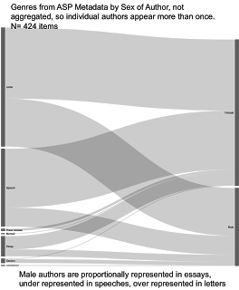
data viz 1

I then looked at the subjects in male authors's letters and speeches. The ASP metadata ascribes multiple subject headings to single items. I used the first attributed subject heading only. This analysis shows that male authors' letters are over represented in the following subjects. Health (83%), Law/government 50%, and religion (50%).Speeches by male authors are under represented in subjects Politics (20%) Economics ((25%) and Law/government (27%)

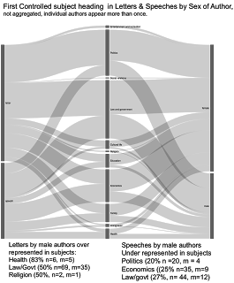
data viz 2
Leaving behind the ASP metadata, I moved on to a corpus linguistics approach to gender in HWS.

Subjecting the subject of woman suffrage to a gender history approach must surmount the obstacle that the term “gender” is absent from the primary sources. But this does not mean that the underlying concepts packed into the contemporary use of the term are absent. Tani Barlow has approached the history of women’s rights (including suffrage) in China by tracing the shifting Chinese language terms for woman/female. The English language does not provide such an easy entry into this project – though the terms for the political movement were numerous, shifting, and subtly different in connotation – woman suffrage, equal suffrage, votes for women, home protection, women’s suffrage, etc. Ellen Dubois
Corpus linguistics, which finds patterns and relationships between words in a body of texts, offers one way to find gender in an English language corpus. To get at “gender,” I looked at gendered pairs such as man/woman, men/women, male/female his/her she/he gentlemen/ladies fathers/mothers. Looking at the diachronic distribution of these terms, I find several things that seem to warrant further investigation.

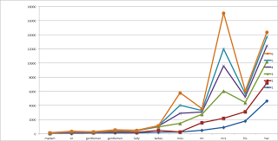
graph 1

1. spike in vol 3 for HER that needs explaining
2. leveling off of his in 5-6 maybe because no items from men?
3. decrease in the use of these gendered pronouns, and while they don’t decline at same rates, perhaps what is most significant is the depersonalization of the overall discourse. This matches the argument Buhle and Buhle made about volumes 5-6 but pushes the trend back further to volume 4
4. dip in vol 2 her is intriguing but will require KWIC and close readings to determine. I’m also curious what the ASP metadata can tell us here does her shift in all types of entries or in specific ones?
5. his, her mr mrs esp his in vol 1 miss and mrs and her in vol 6 which I know from metadata has no entries attributed to men
Also comparing items attributed to males to those attributed to females to determine if there is a gendered pattern of discourse. Keyness, which compares the frequency of words in one text as compared to another, in this case items authored by males versus items authored by females, reveals males used terms that denote binary sex as compared to women's use of gendered pronouns and forms of address.

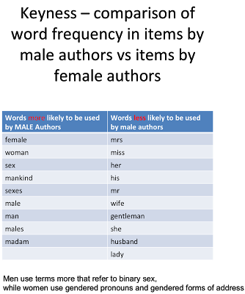
Table 1

These keyness results make me realize I need to look at the diachronic distribution of terms associated with binary sex.
I also looked at collocates, words that appear juxtaposed together at greater than frequency than chance in a body of texts. The most interesting collocates so far are His wife His own Her husband Her own Now I need to determine which items contain these collocates, look at the collocates in context, and explore how they changed over time. The graph shows some interesting correlations and divergences.
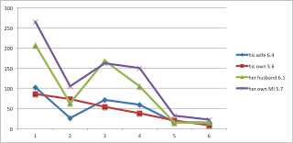
graph 2
I've written all of the above to run by people who are more expert in the history of woman suffrage. So by all means if you have comments, leave them here, tweet @professmoravec or shoot off an email professmoravec at gmail.

using metadata to find paul revere

June 9, 2013
· Sociology · IT · Politics · Data · R
London, 1772.
I have been asked by my superiors to give a brief demonstration of the surprising effectiveness of even the simplest techniques of the new-fangled Social Networke Analysis in the pursuit of those who would seek to undermine the liberty enjoyed by His Majesty’s subjects. This is in connection with the discussion of the role of “metadata” in certain recent events and the assurances of various respectable parties that the government was merely “sifting through this so-called metadata” and that the “information acquired does not include the content of any communications”. I will show how we can use this “metadata” to find key persons involved in terrorist groups operating within the Colonies at the present time. I shall also endeavour to show how these methods work in what might be called a relational manner.
The analysis in this report is based on information gathered by our field agent Mr David Hackett Fischerand published in an Appendix to his lengthy report to the government. As you may be aware, Mr Fischer is an expert and respected field Agent with a broad and deep knowledge of the colonies. I, on the other hand, have made my way from Ireland with just a little quantitative training—I placed several hundred rungs below the Senior Wrangler during my time at Cambridge—and I am presently employed as a junior analytical scribe at ye olde National Security Administration. Sorry, I mean the Royal Security Administration. And I should emphasize again that I know nothing of current affairs in the colonies. However, our current Eighteenth Century beta of PRISM has been used to collect and analyze information on more than two hundred and sixty persons (of varying degrees of suspicion) belonging variously to seven different organizations in the Boston area.
Rest assured that we only collected metadata on these people, and no actual conversations were recorded or meetings transcribed. All I know is whether someone was a member of an organization or not. Surely this is but a small encroachment on the freedom of the Crown’s subjects. I have been asked, on the basis of this poor information, to present some names for our field agents in the Colonies to work with. It seems an unlikely task.
If you want to follow along yourself, there is a secret repository containing the data and the appropriate commands for your portable analytical engine.
Here is what the data look like.
StAndrewsLodge LoyalNine NorthCaucus LongRoomClub TeaParty Bostoncommittee LondonEnemies
Adams.John 0 0 1 1 0 0 0
Adams.Samuel 0 0 1 1 0 1 1
Allen.Dr 0 0 1 0 0 0 0
Appleton.Nathaniel 0 0 1 0 0 1 0
Ash.Gilbert 1 0 0 0 0 0 0
Austin.Benjamin 0 0 0 0 0 0 1
Austin.Samuel 0 0 0 0 0 0 1
Avery.John 0 1 0 0 0 0 1
Baldwin.Cyrus 0 0 0 0 0 0 1
Ballard.John 0 0 1 0 0 0 0

The organizations are listed in the columns, and the names in the rows. As you can see, membership is represented by a “1”. So this Samuel Adams person (whoever he is), belongs to the North Caucus, the Long Room Club, the Boston Committee, and the London Enemies List. I must say, these organizational names sound rather belligerent.
What can we tell from these meagre metadata? This table is large and cumbersome. I am a pretty low-level operative at ye olde RSA, so I have to keep it simple. My superiors, I am quite sure, have far more sophisticated analytical techniques at their disposal. I will simply start at the very beginning and follow a technique laid out in a beautiful paper by my brilliant former colleague, Mr Ron Breiger, called “The Duality of Persons and Groups.” He wrote it as a graduate student at Harvard, some thirty five years ago. (Harvard, you may recall, is what passes for a university in the Colonies. No matter.) The paper describes what we now think of as a basic way to represent information about links between people and some other kind of thing, like attendance at various events, or membership in various groups. The foundational papers in this new science of social networke analysis, in fact, are almost all about what you can tell about people and their social lives based on metadata only, without much reference to the actual content of what they say.
Mr Breiger’s insight was that our table of 254 rows and seven columns is an adjacency matrix, and that a bit of matrix multiplication can bring out information that is in the table but perhaps hard to see. Take this adjacency matrix of people and groups and transpose it—that is, flip it over on its side, so that the rows are now the columns and vice versa. Now we have two tables, or matrices, a 254x7 one showing “People by Groups” and the other a 7x254 one showing “Groups by People”. Call the first one the adjacency matrix A and the second one its transpose, AT. Now, as you will recall there are rules for multiplying matrices together. If you multiply out A(AT), you will get a big matrix with 254 rows and 254 columns. That is, it will be a 254x254 “Person by Person” matrix, where both the rows and columns are people (in the same order) and the cells show the number of organizations any particular pair of people both belonged to. Is that not marvelous? I have always thought this operation is somewhat akin to magick, especially as it involves moving one hand down and the other one across in a manner not wholly removed from an incantation.
I cannot show you the whole Person by Person matrix, because I would have to kill you. I jest, I jest! It is just because it is rather large. But here is a little snippet of it. At this point in the eighteenth century, a 254x254 matrix is what we call Bigge Data. I have an upcoming EDWARDx talk about it. You should come.
Adams.John Adams.Samuel Allen.Dr Appleton.Nathaniel
Adams.John - 2 1 1
Adams.Samuel 2 - 1 2
Allen.Dr 1 1 - 1
Appleton.Nathaniel 1 2 1 -
Ash.Gilbert 0 0 0 0
Austin.Benjamin 0 1 0 0

You can see here that Mr Appleton and Mr John Adams were connected through both being a member of one group, while Mr John Adams and Mr Samuel Adams shared memberships in two of our seven groups. Mr Ash, meanwhile, was not connected through organization membership to any of the first four men on our list. The rest of the table stretches out in both directions.
Notice again, I beg you, what we did there. We did not start with a “social networke” as you might ordinarily think of it, where individuals are connected to other individuals. We started with a list of memberships in various organizations. But now suddenly we do have a social networke of individuals, where a tie is defined by co-membership in an organization. This is a powerful trick.
We are just getting started, however. A thing about multiplying matrices is that the order matters. It is not like multiplying two numbers. If instead of multiplying A(AT) we put the transposed matrix first, and do AT(A), then we get a different result. This time, the result is a 7x7 “Organization by Organization” matrix, where the numbers in the cells represent how many people each organization has in common. Here’s what that looks like. Because it is small we can see the whole table.
StAndrewsLodge LoyalNine NorthCaucus LongRoomClub TeaParty BostonCommittee LondonEnemies
StAndrewsLodge - 1 3 2 3 0 5
LoyalNine 1 - 5 0 5 0 8
NorthCaucus 3 5 - 8 15 11 20
LongRoomClub 2 0 8 - 1 5 5
TeaParty 3 5 15 1 - 5 10
BostonCommittee 0 0 11 5 5 - 14
LondonEnemies 5 8 20 5 10 14 -

Again, interesting! (I beg to venture.) Instead of seeing how (and which) people are linked by their shared membership in organizations, we see which organizations are linked through the people that belong to them both. People are linked through the groups they belong to. Groups are linked through the people they share. This is the “duality of persons and groups” in the title of Mr Breiger’s article.
Rather than relying on tables, we can make a picture of the relationship between the groups, using the number of shared members as an index of the strength of the link between the seditious groups. Here’s what that looks like.
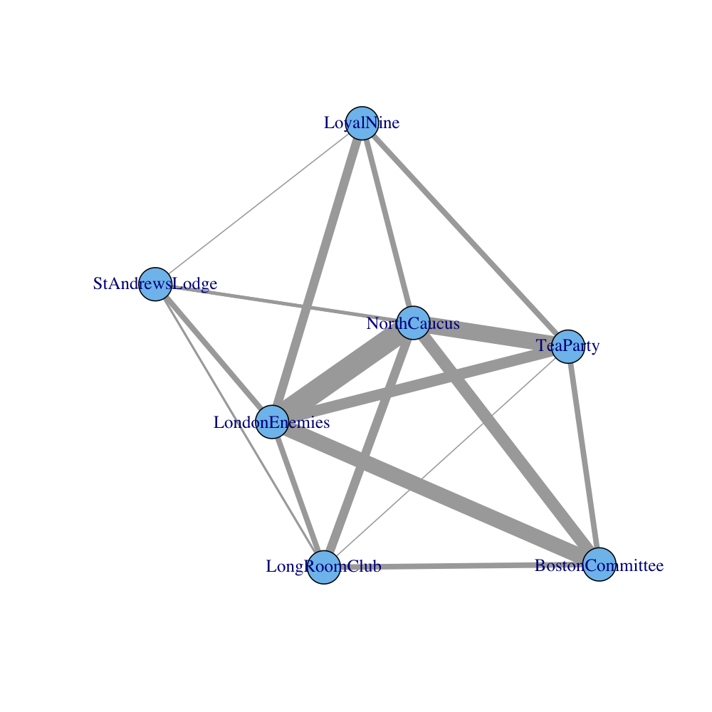
The network of groups
And, of course, we can also do that for the links between the people, using our 254x254 “Person by Person” table. Here is what that looks like.
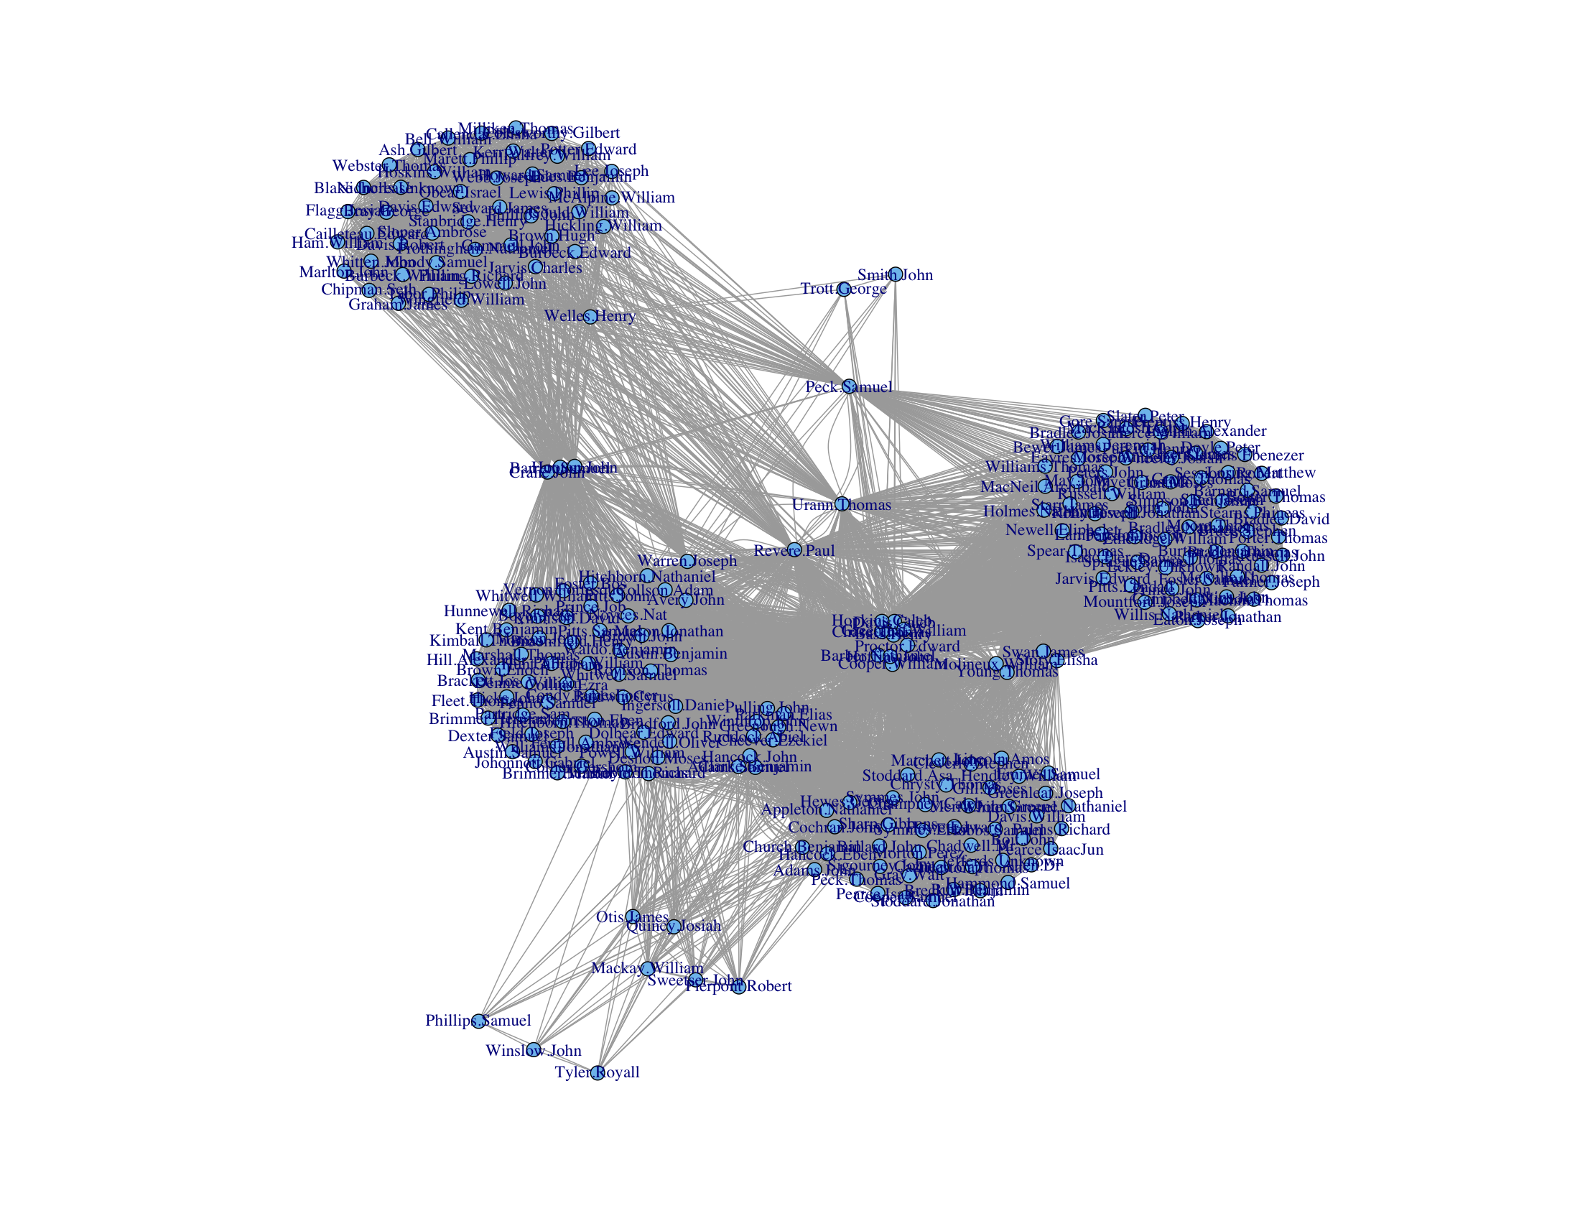
The network of individuals
What a nice picture! The analytical engine has arranged everyone neatly, picking out clusters of individuals and also showing both peripheral individuals and—more intriguingly—people who seem to bridge various groups in ways that might perhaps be relevant to national security. Look at that person right in the middle there. Zoom in if you wish. He seems to bridge several groups in an unusual (though perhaps not unique) way. His name is Paul Revere.
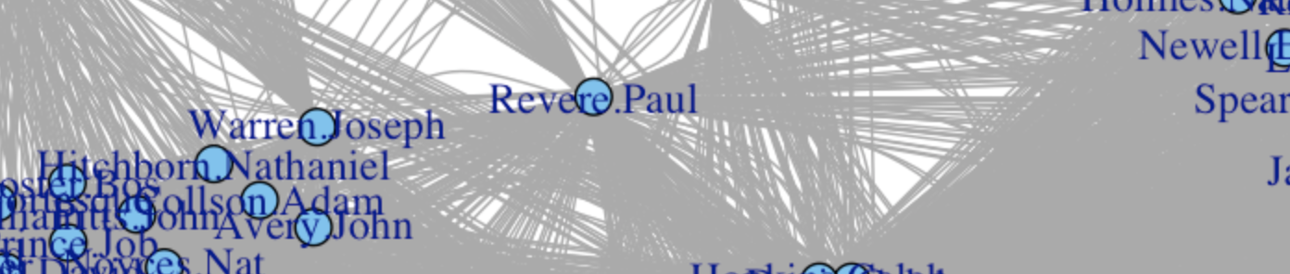
Once again, I remind you that I know nothing of Mr Revere, or his conversations, or his habits or beliefs, his writings (if he has any) or his personal life. All I know is this bit of metadata, based on membership in some organizations. And yet my analytical engine, on the basis of absolutely the most elementary of operations in Social Networke Analysis, seems to have picked him out of our 254 names as being of unusual interest. We do not have to stop here, with just a picture. Now that we have used our simple “Person by Event” table to generate a “Person by Person” matrix, we can do things like calculate centrality scores, or figure out whether there are cliques, or investigate other patterns. For example, we could calculate a betweenness centrality measure for everyone in our matrix, which is roughly the number of “shortest paths” between any two people in our network that pass through the person of interest. It is a way of asking “If I have to get from person a to person z, how likely is it that the quickest way is through person x?” Here are the top betweenness scores for our list of suspected terrorists:
round(btwn.person[ind][1:10],0)
Revere.Paul Urann.Thomas Warren.Joseph Peck.Samuel
3839 2185 1817 1150
Barber.Nathaniel Cooper.William Hoffins.John Bass.Henry
931 931 931 852
Chase.Thomas Davis.Caleb
852 852

Perhaps I should not say “terrorists” so rashly. But you can see how tempting it is. Anyway, look—there he is again, this Mr Revere! Very interesting. There are fancier ways to measure importance in a network besides this one. There is something called eigenvector centrality, which my friends in Natural Philosophy tell me is a bit of mathematics unlikely ever to have any practical application in the wider world. You can think of it as a measure of centrality weighted by one’s connection to other central people. Here are our top scorers on that measure:
> round(cent.eig$vector[ind][1:10],2)
Barber.Nathaniel Hoffins.John Cooper.William Revere.Paul
1.00 1.00 1.00 0.99
Bass.Henry Davis.Caleb Chase.Thomas Greenleaf.William
0.95 0.95 0.95 0.95
Hopkins.Caleb Proctor.Edward
0.95 0.90
Here our Mr Revere appears to score highly alongside a few other persons of interest. And for one last demonstration, a calculation of Bonacich Power Centrality, another more sophisticated measure. Here the lower score indicates a more central location.
> round(cent.bonpow[ind][1:10],2)
Revere.Paul Urann.Thomas Warren.Joseph Proctor.Edward
-1.51 -1.44 -1.42 -1.40
Barber.Nathaniel Hoffins.John Cooper.William Peck.Samuel
-1.36 -1.36 -1.36 -1.33
Davis.Caleb Chase.Thomas
-1.31 -1.31

And here again, Mr Revere—along with Messrs Urann, Proctor, and Barber—appears towards the top or our list.
So, there you have it. From a table of membership in different groups we have gotten a picture of a kind of social network between individuals, a sense of the degree of connection between organizations, and some strong hints of who the key players are in this world. And all this—all of it!—from the merest sliver of metadata about a single modality of relationship between people. I do not wish to overstep the remit of my memorandum but I must ask you to imagine what might be possible if we were but able to collect information on very many more people, and also synthesize information from different kinds of ties between people! For the simple methods I have described are quite generalizable in these ways, and their capability only becomes more apparent as the size and scope of the information they are given increases. We would not need to know what was being whispered between individuals, only that they were connected in various ways. The analytical engine would do the rest! I daresay the shape of the real structure of social relations would emerge from our calculations gradually, first in outline only, but eventually with ever-increasing clarity and, at last, in beautiful detail—like a great, silent ship coming out of the gray New England fog.
I admit that, in addition to the possibilities for finding something interesting, there may also be the prospect of discovering suggestive but ultimately incorrect or misleading patterns. But I feel this problem would surely be greatly ameliorated by more and better metadata. At the present time, alas, the technology required to automatically collect the required information is beyond our capacity. But I say again, if a mere scribe such as I—one who knows nearly nothing—can use the very simplest of these methods to pick the name of a traitor like Paul Revere from those of two hundred and fifty four other men, using nothing but a list of memberships and a portable calculating engine, then just think what weapons we might wield in the defense of liberty one or two centuries from now.

Note: After I posted this, Michael Chwe emailed to tell me that Shin-Kap Han has published an article analyzing Fischer’s Revere data in rather more detail. I first came across Fischer’s data when I read Paul Revere’s Ride some years ago. I transcribed it and worked on it a little (making the graphs shown here) when I was asked to give a presentation on the usefulness of Sociological methods to graduate students in Duke’s History department. It’s very nice to see Han’s much fuller published analysis, as he’s an SNA specialist, unlike me.

When you have a MALLET, everything looks like a nail
Note: this post is part 4, section 2 of my series on whaling logs and digital history. For the full overview, click here.
One reason I'm interested in ship logs is that they give some distance to think about problems in reading digital texts. That's particularly true for machine learning techniques. In my last post, an appendix to the long whaling post, I talked about using K-means clustering and k-nearest neighbor methods to classify whaling voyages. But digital humanists working with texts hardly ever use k-means clustering; instead, they gravitate towards a more sophisticated form of clustering called topic modeling, particularly David Blei's LDA (so much so that I'm going to use 'LDA' and 'topic modeling' synonymously here). There's a whole genre of introductory posts out there encouraging humanists to try LDA: Scott Weingart's wraps a lot of them together, and Miriam Posner's is freshest off the presses.
So as an appendix to that appendix, I want to use ship's data to think about how we use LDA. I've wondered for a while why there's such a rush to make topic modeling into the machine learning tool for historians and literature scholars. It's probably true that if you only apply one algorithm to your texts, it should be LDA. But most humanists are better off applying zero clusterings, and most of the remainder should be applying several. I haven't mastered the arcana of various flavors of topic modeling to my own satisfaction, and don't feel qualified to deliver a full-on jeremiad against its uses and abuses. Suffice it to say, my basic concerns are:
- The ease of use for LDA with basic settings means humanists are too likely to take its results as 'magic', rather than interpreting it as the output of one clustering technique among many.
- The primary way of evaluating its result (confirming that the top words and texts in each topic 'make sense') ignores most of the model output and doesn't map perfectly onto the expectations we have for the topics. (A Gary King study, for example, that empirically ranks document clusterings based on human interpretation of 'informativeness' found Direchlet-prior based clustering the least effective of several methods.)
Ship data gives an interesting perspective on these problems. So, at the risk of descending into self-parody, I ran a couple topic models on the points in the ship's logs as a way of thinking through how that clustering works. (For those who only know LDA as a text-classification system, this isn't as loony as it sounds; in computer science, the algorithm gets thrown at all sorts of unrelated data, from images to music).
Instead of using a vocabulary of words, we can just use one of latitude-longitude points at decimal resolution. Each voyage is a text, and each day it spends in, say, Boston is one use of the word "42.4,-72.1". That gives us a vocabulary of 600,000 or so 'words' across 11,000 'texts', not far off a typical topic model (although the 'texts' are short, averaging maybe 30-50 words). Unlike k-means clustering, a topic model will divide each route up among several topics, so instead of showing paths, we can visually only look at which points fall into which 'topic'; but a single point isn't restricted to a single topic, so New York could be part of both a hypothetical 'European trade' and 'California trade' topic.
With words, it's impossible to meaningfully convey all the data in a topic model's output. Geodata has the nice feature that we can inspect all the results in a topic by simply plotting them on a map. Essentially, 'meaning' for points can be firmly reduced a two-dimensional space (although it has other ones as well), while linguistic meaning can't.
Here's the output of a model, plotted with high transparency so that a point on the map will appear black if it appears in that topic in 100 or more log entries. (The basic code to build the model and plot the code is here--dataset available on request).
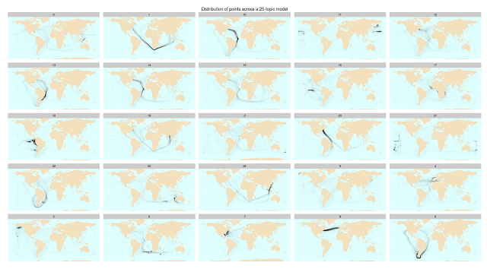
Click to enlarge
At first glance, topic modeling performs far better than it has any right to on this sort of data. A 25-topic model yields a number of distinctively 'whaling' topics (see below); if I had a dataset with no metadata but a strong sense of what these map regions might mean, I might be able to separate out whaling by picking voyages heavy in topics 18, 5, 21, 16, and 11, each of which roughly corresponds to a few of the whaling grounds in the master chart. I was frankly surprised how well this worked; I was expecting less cognizable chunks (I thought, based on my fuzzy understanding of the math, that the Atlantic crossing might be split into two topics, for example, and that most trips would draw from several smaller chunks like that. Maybe this would be true of a 100-topic model.)
The optimistic take on this is pretty obvious:
- Topic modelling is amazing;
- Why not topic model everything?
Since that's so straightforward, let me give the pessimistic take instead.
In short, the results are not always magic, and the way that we interpret textual topic models doesn't seem as robust as geographic analysis. For example: if I ask MALLET (the software package most people use for topic modelling) for a 9-topic model instead of a 25-topic one, things look all right on first glance: you even get some nice features, like separate clusters for the routes from and to US east coast on the trade winds. Closer inspection, though, reveals some strange decisions on the part of the clustering, such as binning the western Pacific whaling grounds in with the transatlantic clipper routes (middle right), or trade around Florida with the Bering straits (lower right).
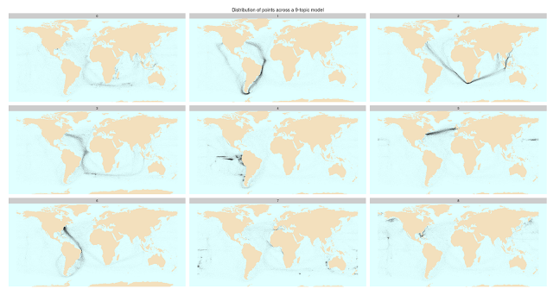
Let me blow up that topic 5 so you can see how strange it is:
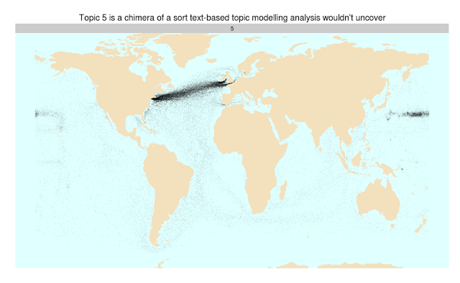
The algorithm is obviously combining two very different clusters together; whaling from Hawaii, and the eastern seaboard–England shipping route. But the standard way of interpreting topic model results, looking at the top words in each topic, might have led me to label it as "transatlantic shipping", which encompasses 9 of the ten top places in the topic. (The 10th is Guam, which isn't particularly close to the larger cluster in the Pacific; no individual point in there is all that common). Are there similar sub-threshold parasite topics in MALLET output on textual data that we don't see? I'm curious if someone who knows LDA better than I can explain why this might be a quirk of this particular source, rather than a general phenomenon of the clustering algorithm. (Topic 0 in the 25-topic model has similar problems).
This is a case where I'm really being saved by the restrictive feature space of data. If I were interpreting these MALLET results as text, I might notice it, for example, but start to tell a just-so story about how transatlantic shipping and Pacific whaling really are connected. (Which they are; but so is everything else.) The absurdity of doing that with geographic data like this is pretty clear; but interpretive leaps are extraordinarily easy to make with texts.
Obviously this is an extreme test of LDA; that it performs at all is to its credit, and weird clustering results like this are probably a result of the differences between this and the data MALLET is designed for. Better priors and maybe some other sounder assumptions might fix this somewhat; ship's paths are not texts, even in the shape of their data. (In this case, I bet the model could be made a lot better by fine-tuning the alpha and beta parameters to expect less breadth of documents across words; does that sound right? For the record, their distribution across geopoints isn't too far off Zipf's law after the first ten points.)
The reason I find it useful at all for understanding topic modeling is that it's also extreme, in that it's much easier to visually see the whole results of what a topic model spits out, not just the top ten words or top 20 results. One of the things I always say about Bookworm is that humanists need search interfaces that return more than just a unidimensional ordered list. We need that for interpreting clustering results much more than we need it for search results; but it's extremely hard to do. The nice thing about geographic data is that we have a ready-made contextual system for spatially situating points that let us instantly see outliers like above. That doesn't really exist for texts. (Using word clouds for topic model results, as Elijah Meeks does, is a great idea, but word clouds are just an alternate univariate way of visualizing ordered lists.)

The lesson of the whales I'd want to apply here is that we need to be able to tune and return our results in concert with outside evidence; outside metadata, visual inspection, or (ideally) both. That's not to say LDA is completely inscrutable; Matt Jockers, for example, has done just this sort of iterative improvement on the models of the Stanford literary corpus, and that lets him made some great conclusions from the data. But even those as deep into the plumbing as Jockers, Ted Underwood, or Allen Riddell will have a hard time bringing other humanistic readers along on the interpretive choices they make in tuning their topic models, and instead will have to rely on protestations of authority. Which isn't terrible—it's standard interpretive practice—but loses one of the big benefits I've seen in humanistic research, which is that it can help open up the act of humanistic inference to non-experts.
And most humanists who do what I've just done—blindly throwing data into MALLET—won't be able to give the results the pushback they deserve. I feel like I have some sense of how points cluster in high-dimensional cartesian spaces, which helps me troubleshoot k-means results, but find myself completely unable to to intuit what might go wrong in 25-dimensional simplexes. I don't think I'm alone: and I'm not sure that we should too enthusiastic about interpreting results from machine learning which we can only barely steer.
So there are cases where topic modeling can be useful for data-creation purposes; I'm satisfied with my other way of extracting whaling voyages, for instance, but topic models would work here. But as artifacts to be interpreted on their own, topic models may be less useful. The downside of too-aggressive topic modeling is that it leads occasionally leads us to treat junk as an oracle. (This isn't specific to topic modeling, obviously: other methods I've written about in the past, like principal components analysis, can be ever worse).
A poorly supervised machine learning algorithm is like a bad research assistant. It might produce some unexpected constellations that show flickers of deeper truths, but there are lots of ways to get creative rearrangements. If it's not doing the task we want, it's time to give it some clearer instructions, or to find a new one.

Edward Rolf Tufte (/ˈtʌfti/;[1]born March 14, 1942) is an American statistician and professor emeritus of political science, statistics, and computer science at Yale University.[2] He is noted for his writings on information design and as a pioneer in the field of data visualization.[3]
Biography[edit]
Edward Rolf Tufte was born in 1942 in Kansas City, Missouri, to Virginia Tufte and Edward E. Tufte (1912–1999). He grew up in Beverly Hills, California, where his father was a longtime city official,[4] and he graduated from Beverly Hills High School.[5] He received a BS and MS in statistics from Stanford University and a PhD in political science from Yale.[6] His dissertation, completed in 1968, was entitled The Civil Rights Movement and Its Opposition. He was then hired by Princeton University's Woodrow Wilson School, where he taught courses in political economy and data analysis while publishing three quantitatively inclined political science books.
In 1975, while at Princeton, Tufte was asked to teach a statistics course to a group of journalists who were visiting the school to study economics. He developed a set of readings and lectures on statistical graphics, which he further developed in joint seminars he taught with renowned statistician John Tukey, a pioneer in the field of information design. These course materials became the foundation for his first book on information design, The Visual Display of Quantitative Information.[7][8]
After difficult negotiations with mainline publishers failed, Tufte decided to self-publish Visual Display in 1982, working closely with graphic designer Howard Gralla. He financed the work by taking out a second mortgage on his home. The book quickly became a commercial success and secured his transition from political scientist to information expert.[7]
On March 5, 2010, President Barack Obama appointed Tufte to the American Recovery and Reinvestment Act's Recovery Independent Advisory Panel "to provide transparency in the use of Recovery-related funds".[6]

Work[edit]
Tufte is an expert in the presentation of informational graphics such as charts and diagrams, and is a fellow of the American Statistical Association. He has held fellowships from the Guggenheim Foundationand the Center for Advanced Study in the Behavioral Sciences.
He is intensely critical in the self-editing process. He pulls in and casts out ideas from books, journals, posters, auction catalogs, and other less common sources. He invites others to critique his work in-progress and may nurture dozens of ideas over months in various states of growth and fruition. He deletes almost every photograph he takes. Over time, he deletes most of what he writes on his own forum, ET Notebooks. Every printing of every book corrects numerous small blemishes, ranging from color registration to kerning and hinting.[citation needed]

Information design[edit]
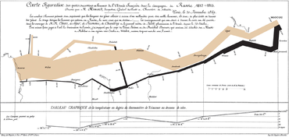
Charles Joseph Minard's Carte Figurative illustrates facts related to French Invasion of Russia1812.
Tufte's writing is important in such fields as information design and visual literacy, which deal with the visual communication of information. He coined the word chartjunk to refer to useless, non-informative, or information-obscuring elements of quantitative information displays. Tufte's other key concepts include what he calls the lie factor, the data-ink ratio, and the data density of a graphic.[9]
He uses the term "data-ink ratio" to argue against using excessive decoration in visual displays of quantitative information.[10] In Visual Display, Tufte explains, "Sometimes decoration can help editorialize about the substance of the graphic. But it is wrong to distort the data measures—the ink locating values of numbers—in order to make an editorial comment or fit a decorative scheme."[11]
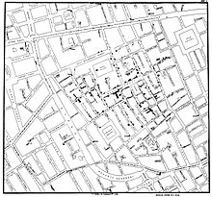
John Snow's map of the 1854 cholera outbreak in Soho
Tufte encourages the use of data-rich illustrations that present all available data. When such illustrations are examined closely, every data point has a value, but when they are looked at more generally, only trends and patterns can be observed. Tufte suggests these macro/micro readings be presented in the space of an eye-span, in the high resolution format of the printed page, and at the unhurried pace of the viewer's leisure.
He uses several historical examples to make his case. These include John Snow's cholera outbreak map, Charles Joseph Minard's Carte Figurative, early space debris plots, Galileo Galilei's Sidereus Nuncius, and Maya Lin's Vietnam Veterans Memorial. For instance, the listing of the names of deceased soldiers on the black granite of Lin's sculptural memorial is shown to be more powerful as a chronological list rather than as an alphabetical one. The sacrifice each fallen individual has made is thus highlighted within the overall time scope of the war.[12] In Sidereus NunciusGalilei presents the nightly observations of the moons of Jupiter in relation to the body itself, interwoven with the two-month narrative record.[13]

Criticism of PowerPoint[edit]
Tufte has criticized the way Microsoft PowerPoint is typically used. In his essay "The Cognitive Style of PowerPoint", Tufte criticizes many aspects of the software:
- Its use to guide and reassure a presenter, rather than to enlighten the audience;
- Its unhelpfully simplistic tables and charts, resulting from the low resolution of early computer displays;
- The outliner's causing ideas to be arranged in an unnecessarily deep hierarchy, itself subverted by the need to restate the hierarchy on each slide;
- Enforcement of the audience's lockstep linear progression through that hierarchy (whereas with handouts, readers could browse and relate items at their leisure);
- Poor typography and chart layout, from presenters who are poor designers or who use poorly designed templates and default settings (in particular, difficulty in using scientific notation);
- Simplistic thinking—from ideas being squashed into bulleted lists; and stories with beginning, middle, and end being turned into a collection of disparate, loosely disguised points—presenting a misleading facade of the objectivity and neutrality that people associate with science, technology, and "bullet points".
Tufte cites the way PowerPoint was used by NASA engineers in the events leading to the Space Shuttle Columbia disaster as an example of the many problems. The software style is designed to persuade rather than to inform people of technical details. Tufte's analysis of a NASA PowerPoint slide is included in the Columbia Accident Investigation Board’s report—including an engineering detail buried in small type on a crowded slide with six bullet points, that if presented in a regular engineering white paper, might have been noticed and the disaster prevented.[14][15]
Instead, Tufte argues that the most effective way of presenting information in a technical setting, such as an academic seminar or a meeting of industry experts, is by distributing a brief written report that can be read by all participants in the first 5 to 10 minutes of the meeting. Tufte believes that this is the most efficient method of transferring knowledge from the presenter to the audience and then the rest of the meeting is devoted to discussion and debate.[16]

Small multiple[edit]
One method Tufte encourages to allow quick visual comparison of multiple series is the small multiple, a chart with many series shown on a single pair of axes that can often be easier to read when displayed as several separate pairs of axes placed next to each other. He suggests this is particularly helpful when the series are measured on quite different vertical (y-axis) scales, but over the same range on the horizontal x-axis (usually time).

Sparkline[edit]
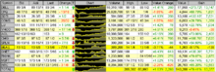
Earliest known implementation of sparklines, around January 1998 by interaction designer Peter Zelchenko for programmer Michael Medved and the QuoteTracker application (sold to TD Ameritrade).
Although Tufte is said to have invented sparklines, in actuality he invented only the name and popularized it as technique.[17]Sparklines are a condensed way to present trends and variation, associated with a measurement such as average temperature or stock market activity, often embedded directly in the text; for example: The Dow Jones index for February 7, 2006 .[18][19] These are often used as elements of a small multiple with several lines used together. Tufte explains the sparkline as a kind of "word" that conveys rich information without breaking the flow of a sentence or paragraph made of other "words" both visual and conventional. To date, the earliest known implementation of sparklines was conceived by interaction designer Peter Zelchenko and implemented by programmer Mike Medved in early 1998.[20]

Sculpture[edit]
Beyond his academic endeavors over the years, Tufte has created sculptures, often large outdoor ones made of metal or stone,[5] which were first primarily exhibited on his own rural Connecticut property. In 2009–10, some of these artworks were exhibited at the Aldrich Contemporary Art Museum in Ridgefield, Connecticut, in the one-man show Edward Tufte: Seeing Around.[21] The Tufte sculpture garden in Woodbury, Connecticut is open to the public one day per year.[22]
In his sculpture, he digs through sources ranging from other art and other genres (most notably Feynman diagrams), to flea markets, nuclear power plants, and fields of grass. He is in search of forms and ideas from which to build models, table pieces, and occasionally larger landscape pieces. Even some nominally finished, large scale works are reworked heavily. But at the same time, some random sculptural equivalents of brush strokes or artifacts of a piece's former life are retained, a degree of wabi-sabi, as may be seen in Rocket Science (circa 2006–9, Hogpen Hill, Connecticut).[citation needed]
In 2010, "the man known as 'ET'... opened a gallery, ET Modern, in New York City's Chelsea Art District"[23] at 11th Avenue and 20th Street.[24] The gallery closed in 2013 "after 3.5 good years".[25]

